2016 Annual Meeting
  - A Year in Review

  - June 30, 2016

CHS Board of Trustees
Barrett, Richard E. (Dick)  Term Expires 2018 | Retired, Battelle Institute
Chandler, Bonnie  Term Expires 2018 | Retired, Columbus Metropolitan Library  History, Genealogy, Travel Division
Chris Dean, CPA  Term Expires 2016  treasurer | Partner  GBQ Partners, LLC  230 West Street, Columbus, Ohio 43215
Frush, Michael A., CPA  Term Expires 2017 | President  Frush & Associates Inc  699 South Front Street  Columbus, OH 43206
Hummel, Gretchen  Term Expires 2018 | retired from the law firm of McNees, Wallace & Nurick, LLC
Hunter, Robert  Term Expires 2016 | Sports Columnist  The Columbus Dispatch  Sports Columnist  34 S. 3rd Street  Columbus, Ohio 43215
Meyers-Walker, Elise  Term Expires 2018 | Research Analyst  Jobs Ohio  41 South High Street, Suite 1500  Columbus, Ohio 43215
O’Neal, Ron  Term Expires 2018 | Franklin County Veterans Memorial Parking Facility
O’Shaughnessy, Maryellen  Term Expires 2018 | Franklin County Clerk of the Court of Common Pleas  373 S. High St., 23rd floor  Columbus, Ohio 43215
Sewalk, David  Term Expires 2018 | Director of Conversions & Infrastructure | Technology & Conversions | The Huntington National Bank
Tootle, James R. , Ph.D  Term Expires 2016  Vice President | Assistant Dean, Retired  The Ohio State University  Colleges of Arts and Sciences
Walters, Ben  Term Expires 2018  President | Owner/Operator  North Market Spices  59 Spruce St.  Columbus, OH 43215
Walters, Christy  Term Expires 2018 | Events Manager  Ballet Met Columbus  322 Mt. Vernon Ave.  Columbus, Ohio 43215
Widman, Ron  Term Expires 2017 | Film/Video Archivist

A Year in Review 2015-2016
The past year for the Columbus Historical Society (CHS) was a transitional time. Staff changes, new partnerships, new interns, new office equipment, new grants and new exhibits made for an eventful year in the CHS offices and museum. The CHS continues to make significant strides in reaching new audiences, being more inclusive, and growing and protecting our archives.

Exhibits
Once again the CHS saw over 28,000 guests through our museum doors in 2015-16. Visitors were engaged with a variety of exhibits and programs throughout the year in our space.

CHS exhibits-
- History Vignettes- (4/2015- present) significant items from the archives of the CHS and other significant Central Ohio collections
- Reaching for the Sky: History of Columbus Aviation (4/15/ 2015-/5/2016) in partnership with the Ohio History Connection and COSI
- A Bird’s Eye View of Central Ohio (5/2015-5/2016) featuring aerial images of Columbus over the decades
- Poindexter Village: A Portrait in Stories (6/2016-2017) our newest exhibit.

Visiting Exhibits-
- Opening in September (9/2016-12/2016)- A Century of Service: 110 Years of the Red Cross in Central Ohio

Teaming up with the COSI design staff to create Reaching for the Sky: The History of Columbus Aviation set a new standard for CHS exhibits. Using CHS historians along with design professionals created an outstanding exhibit that received great reviews and brought new audiences to the CHS. Women’s pilot groups, aviation enthusiasts, and the general public were delighted by the stories, milestones, histories, and achievements they learned about through this display.
Our newest exhibit was truly a community effort. Representatives from the Columbus Museum of Art, The Ohio History Connection, WOSU, The James Preston Poindexter Foundation, Columbus Metropolitan Housing Authority, National Afro-American Museum and Cultural Center, The Ohio State University Department of Art & Technology, The Ohio State University Department of History, Greater Columbus Council of Elders, Second Baptist Church, The Ohio State University African American and African Studies Community Extension Center, Cirqua Studios, and 3 Sisters Graphics all worked together to create the amazing display. Thanks to the generous support from CMHA the group was able to hire professional designers, curators, historians, and a facilitator to ensure the success of the group.
We also participated once again with an off site exhibit at the State Fair and we continue our partnership with OSU by presenting the Downtown/Franklinton documentary and short pieces from their new show Broad and High on monitors in our museum.

Programs/Events

8/ 11/ 2015 Teacher Resource Fair @COSI. Once again CHS participated in the annual teacher resource fair. Over 150 teachers from all over Central Ohio attend this event to learn about educational opportunities for their students.
8/25/2015 Otterbein student museum tour/interview. CHS participated in a student project for Otterbein students. A museum tour and interview was conducted by staff.
8/ 27/2015 OSU Job Fair. This annual event targets interns, OSU work study students, and volunteers. Each year CHS acquires work study students to act as docents in our museum, archivists, and office staff from the one day event.
10/8/2015 OSU student group interview. This time a group from OSU came in the interview staff and tour museum for a class project.
10/15/2015 Leadership Columbus class of 2016 exhibit tour and discussion of CHS.
10/22/2015 Columbus School for Girls exhibit tour and founding of Columbus program.
11/8/2015- “A Wicked Evening” fundraiser and book launch. Over 75 guests attended an evening of food, drink, spooky tunes and stories of Columbus.
12/10/2015 “21st Century Learning Lab- Germs”, in conjunction with COSI and OSU College of Pharmacology.
1/26/2016 OSU summer internship fair
2/4/2016- “COSI After Dark” Evening
2/9/2016 CMC New University faculty welcome evening @ COSI
3/3/2016 “COSI After Dark” Evening
5/18/2016 “21st Century Learning Lab- Germs” in conjunction with COSI and OSU College of Pharmacology.
5/18/2016 Columbus Metropolitan Club forum “Poindexter Village’s Legacy”
5/19/ 2016 “21st Century Learning Lab- Germs” in conjunction with COSI and OSU College of Pharmacology (presented to students from Ohio School for the Blind).
6/3/2016 “Poindexter Village: A Portrait in Stories” Partners Preview
6/5/ 2016 “Poindexter Village: A Portrait in Stories” General Public opening/ Docent tours
6/16/2016 WOSU’s All Sides with Anne Fisher “Remembering Poindexter Village” radio program
6/18/2016 “Inspired by: Aminah Robinson” Columbus Early Childhood Learning Center and the Champion Intergenerational Center art show and sale.
6/30/2016 Poindexter Village: A Portrait in Stories presents, “An Evening of History: A Panel Discussion and Annual Members Meeting”

Bus Tours

In 2015 our regular bus tour series ran the 4th Saturdays May – October. In addition to the 6 public tours the CHS conducted 8 additional private tours for groups including but not limited to-
Treasure Grove Travel
Bexley Senior Center
Experience Columbus Midwest Travel Writers Conference
Leadership Columbus “Onboarding Columbus” program

Archives/Collections

2015-2016 Highlights for the Archive Committee- Bonnie Chandler, head archives/collections committee
This year, the Archives Committee has been following the recommendations of the Museum Assessment Program awarded to CHS in 2015 by American Alliance of Museum’s by defining the role of archives; drafting a Collecting Plan which will create a focus for accepting and acquiring donations; and working on better organization and preservation of existing collections.
In December 2015, the society was contacted by outgoing Mayor Coleman’s office to see if we would like to acquire any items from his 16 years in office. And in January we went to City Hall to pick up over 800 items including, photograph, speeches and memorabilia.
In April 2016, we were awarded an archival preservation grant for just under $2,000 from the Ohio Historical Records Advisory Board to catalog and preserve our growing Columbus Mayor Collections which includes material from Mayors Jack Sensenbrenner, Gregory Lashutka and the newly acquired Michael B Coleman.
We also continue to work with the Columbus Metropolitan Library by uploading images into Columbus Memory an online digital collection. This year we will upload images from Ameriflora held in 1992 at Franklin Park Conservatory and aerial images of the county from the 1970s and 1980s.

CHS Staffing/Operations

In October of 2015 the CHS welcomed longtime volunteer Aimee Briley to our staff as our Associate Director. Aimee has a long resume of working with volunteers, collections, programing, and events. Previously Aimee had volunteered with the CHS for 6 years and won the Volunteer of the Year award in 2012. It is a pleasure to have her enthusiasm, dedication, and knowledge in our offices. Aimee has been working extensively with our interns, volunteers, and work study staff, to orient them to our organization and keep them busy.
In December 2015, Huntington Bancshares was kind enough to donate over $4,000 worth of computers, scanners and printers plus install time to the CHS. This was the first complete upgrade of the CHS office equipment in over 8 years. We are very grateful for the generous donation of refurbished equipment that truly brings our office into the 2010’s!
2015-2016 Staffing- Aimee Briley, Associate Director
From June 2015-June 2016, the society has had the privilege of working with 40 work-study students, volunteers, and interns who have completed over 2621 hours of work. It is no exaggeration to say, that without these individuals we would be unable to keep our exhibit doors open Wednesday-Sunday 11-5 or accomplish so many of the critical operating tasks of our organization. Some of the many tasks they have performed this year include: exhibition docenting, guest relations, archival work, social media, writing and publishing our monthly newsletter, mailings, event management, historical research for CHS and the public, website maintenance and creation, membership renewals, educational programs, and grant research and writing. They deserve our gratitude for choosing to spend their talent, time, and energy with the Columbus Historical Society.

Organizations the CHS Partnered with 2015-2016
All Sides with Anne Fisher
Bexley Public Library
City of Columbus
Coalition for Responsible & Sustainable Development for the Near East Side
Columbus International Program
Columbus Metropolitan Housing Authority
Columbus Metropolitan Library
Columbus Monthly
Columbus Museum of Art
Columbus School for Girls
Columbus State Community College Work Study Program
Community Shares of Mid- Ohio
Conestoga
COSI
Eckerd Workforce Development
Experience Columbus
Experience Columbus Certified Tourism Ambassador Program
Hanover College
Huntington Bancshares
Jones Day
Leadership Columbus
Leading the Way
National Afro- American Museum & Cultural Center
Original Columbus Airport Terminal Restoration Project
Partners Achieving Community Transformation
Signal Travel
The City of Bexley, Seniors Activities
The Columbus Dispatch
The Columbus Metropolitan Club
The Graham School
The James Preston Poindexter Foundation
The Ohio History Connection
The Ohio State Fair
The Ohio State University African American and African Studies Community Extension Center
The Ohio State University department of Art & Technology
The Ohio State University department of History
The Ohio State University Nisonger Center Transition Options in Postsecondary Settings Program
The Ohio State University Work Study Program
The American Red Cross
Treasure Trove Travel
University of Oklahoma
WOSU

Financials
Income:

Expenditures:

Exp

Expenditures:
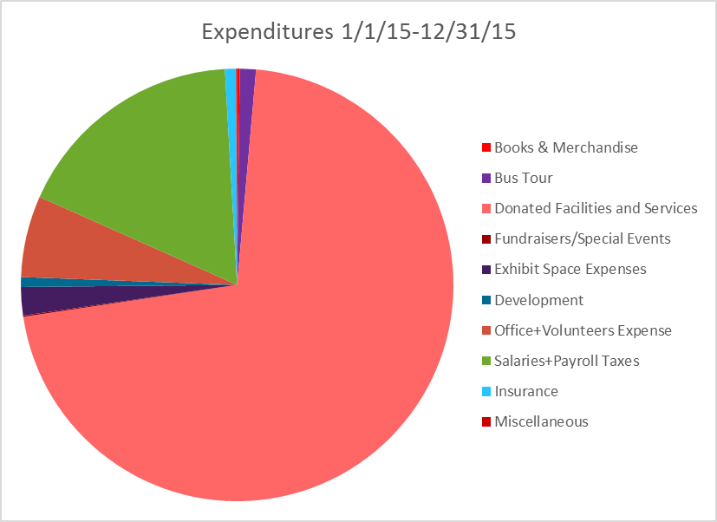

With support from:

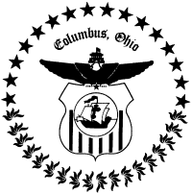
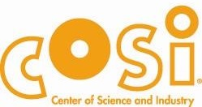

The Thomas C. and Mary Ann Hays Family Charitable Trust

